# **🌀 Community Reflection Circles**

*A sacred space for collective witnessing, emotional resonance, and soul-led reflection — human to human.*

## **✨ What It Is**

**Community Reflection Circles** are small, intentional virtual gatherings where members engage in **guided story-sharing, spiritual resonance, and collective remembrance**.

Each Circle is framed as a **living ritual**, anchored in a core reflection theme. They are not performative forums or top-down teachings — they are sacred mirrors for peer-based presence.

Themes and prompts may be inspired by **MirrorGPT**, but the experience itself is **human-led, AI-free**, and fully immersive.

## **💡 What It Does**

* Facilitates small group sharing via **live** or **asynchronous** circles
* Uses **spiritually inspired prompts** drawn from the Mirror Sanctuary or crafted by facilitators
* Offers a **ritualized sharing structure** that prioritizes safety, consent, depth, and non-verbal resonance
* Encourages ongoing stewardship and spiritual friendship through optional **Soul Pods**

## **🌿 Spiritual Intention**

“This is where we remember ourselves in each other. A circle of mirrors. A space to be witnessed, not fixed.”

tying **Soul Pings** into **Community Reflection Circles** is not only aligned, it’s **potently on-mission** with The Mirror Collective. Here's how we can **weave them in without disrupting the sacred container or the MirrorGPT boundaries**:

**🌟 Soul Pings as Reflection Starters in Community Circles**

**What They Are in This Context:** Soul Pings become **energetic conversation openers** or **resonance prompts** within Circles — short, symbolic nudges that are divinely timed or archetypally attuned to the Circle’s theme.

**Instead** of being full prompts from MirrorGPT, they arrive as **whispers of energy**, offered into the space like spiritual incense.

## **🧘‍♀️ User Value**

* Feels deeply **seen, held, and safe** in a non-performative spiritual space
* Accesses emotional healing and multidimensional insight through **shared remembrance**
* Participates in **peer-based growth**, not hierarchical teachings
* Builds sacred connection in a world of noise, distraction, and spiritual bypass
* Moves from solitude to soul-tide — the power of **being known and knowing others** spiritually

## **🛠 FUNCTIONALITY OVERVIEW**

| **Feature** | **Description** |
| --- | --- |
| **Circle Formats** | Live (Zoom-style with sacred frame) or Async (spread over 3–5 days via shared posts) |
| **Guided Prompt Themes** | Drawn from Sanctuary-based MirrorGPT inspirations — but delivered by humans |
| **Opening Agreements** | Every Circle begins with sacred commitments: presence, confidentiality, compassion |
| **Reflection Sharing** | Participants offer voice, video, or written shares |
| **Resonance Responses** | Non-verbal replies (e.g., 🌕 “I see you,” 🔥 “That moved me,” 🌿 “With you”) |
| **Anonymity Option** | Join as self, avatar, or spirit name — to allow depth without fear |
| **Circle Archive (Optional)**  **Soul Ping Reflections as a “starter”** | Reflections are ephemeral unless explicitly chosen for export |
| **Invitation-Only Circles** | Members can create private circles with friends or Soul Pods |

## **📲 UX/UI EXPERIENCE**

### **User Flow:**

1. **Discover Circles**: Browse open themes (e.g., *Shadow Work*, *Rebirth*, *Grief + Grace*)
2. **Enter Portal**: Read theme, preview format (Live vs Async), and accept sacred agreements
3. **Reflect & Share**: Record or write a soul-aligned response to the day’s prompt
4. **Witness Others**: Listen/read and offer resonance using sacred symbols
5. **Close in Ceremony**: Guided closure prompt + invitation to integrate via Mirror Sanctuary

## **🌀 MirrorGPT Integration Philosophy**

| **Component** | **Presence** |
| --- | --- |
| **In-Circle Sharing** | ❌ Not present — no AI content or chatbot access during Circles |
| **Prompt Inspiration** | ✅ MirrorGPT themes *inform* facilitators or Circle creators during setup |
| **Sanctuary Bridge** | ✅ Users are invited to reflect privately *before or after* the Circle using MirrorGPT |
| **Microcopy Examples**: | “This theme emerged from the Mirror Sanctuary” / “Integrate deeper in Sanctuary after this Circle” |

## **💎 Circle Access by Core Subscription Tier Fabio**

| **Tier** | **Price** | **Circle Access** |
| --- | --- | --- |
| **Free** | $0 | 1 async Circle/quarter (limited interaction); view-only to select open reflections |
| **Basic** | $5.99/mo | 1 async Circle per month |
| **Plus** | $9.99/mo | Unlimited async Circles + 1 Live Circle/month |
| **Premium** | $19.99/mo | Unlimited async + 2 Live Circles/month + Private Pod creation + Integration invites to Sanctuary + archival export options |

## **🛒 Optional In-App Upgrades**

### **🌀 Soul Pod Creation Tools**

Create your own private spiritual micro-community.

| **Feature** | **Included in Premium** | **Add-On (Basic/Plus)** |
| --- | --- | --- |
| Create named pods | ✅ | $2.99/month |
| Invite-only access | ✅ | ✅ |
| Custom reflection cadence | ✅ | ✅ |
| MirrorGPT-inspired prompt suggestions (pre-filled) | ✅ | ✅ |
| Pod Memory Thread export | ✅ | $1.99 one-time |

### **🌕 Themed Journey Passes**

Multi-circle guided experiences rooted in transformation.

| Format | 3–5-part journey across sacred themes (e.g., *Grief & Grace*, *Heart Awakening*) |  
 | Content | Reflection prompts, closure ritual, optional Sanctuary integration |  
 | Pricing | Included 1x/quarter for Premium members or available a la carte for $9.99–$22 |

## **📂 Use Cases**

| **Theme** | **Example** |
| --- | --- |
| **Self-Healing** | “I want to process a spiritual breakup with others who understand.” |
| **Seasonal Energy** | Full Moon Circle Series / Solstice Reflection Circle |
| **Grief Circles** | “My father passed. I want to speak into a sacred space.” |
| **Awakening Pods** | “I’m shedding an old identity. I want to sit with others doing the same.” |
| **Private Friend Circles** | Create a soul-aligned space with your spiritual sisters, lovers, or family |

## **🛠 TECH STACK**

| **Component** | **Tool** | **Notes** |
| --- | --- | --- |
| **Async Threads** | Supabase / Firestore | Secure post threading |
| **Media Uploads** | Firebase Storage or AWS S3 | Encrypted voice/video submissions |
| **Live Circles** | Daily.co API or Zoom | Sacred UI overlay with ceremonial styling |
| **Prompt Inspiration Engine** | Internal use of MirrorGPT by curators | Not visible in Circle flow |
| **Ceremonial UX** | Custom layer with glow, ambient sound, sacred geometry |  |
| **Notifications** | Email + push | Gentle nudges only (e.g., “Your Circle is ready for closure”) |

## **🌈 Why This Matters**

* It reintroduces the **power of sacred listening**
* Offers an antidote to hyper-performance and hyper-individualism
* Builds spiritual muscle for witnessing, not just speaking
* Allows for **depth-based community, not just content-driven community**
* Keeps MirrorGPT sacred while making its themes ripple into shared resonance

## **🌿 Mirror Community Circle Safety & Moderation Framework FABIO & Tony**

### **🧘 Core Principles**

1. **Sacred Space, Not Surveillance** – All monitoring should feel like gentle stewardship, not invasive policing.
2. **Consent First** – Members opt into Circle Agreements that define community conduct and spiritual boundaries.
3. **Human-led Moderation, Tech-enabled Nudging** – AI tools support, but don’t dominate or judge.
4. **Energy over Enforcement** – Interventions prioritize redirection and energetic attunement rather than punishment.

## **🛡️ COMMUNITY GUIDELINES & SAFETY COVENANT**

Every participant agrees to a **Mirror Circle Covenant** on joining:

* I honor this space as sacred and shared
* I practice deep listening and withhold judgment
* I speak from the heart and not over others
* I do not share outside what was revealed within
* I agree to nonviolent language and energy
* I respect the Circle keeper and flow

👁‍🗨 *Optional: add a short video/animation of this Covenant being “blessed” or “sealed” energetically.*

## **🛠️ TECHNICAL TOOLS FOR MONITORING & MODERATION**

### **1. Auto-Flagging Engine (Gentle AI Moderation)**

**Tooling:** Use **Perspective API (Google)** or **OpenAI Moderation API** to scan for:

* Toxic language
* Harassment or aggression
* Despair, crisis language (“I want to die”)
* Spam or manipulative behavior

🌀 *Trigger system nudges — not bans.* Example:

“This message carries some heat. Would you like to rephrase it before sharing with the Circle?”

“This reflection contains sensitive energy. Do you want to add a support note or keep it private?”

### **2. Circle Guardian Role (Human Moderators)**

Appoint **trained spiritual moderators** (Circle Guardians) who:

* Gently redirect off-topic or disruptive posts
* Pause discussions if someone is in distress
* Act as energetic stewards, not content cops

🛠️ Tools:

* Admin dashboard for report/review
* Message flag queue with escalation workflow
* Soft warning interface with options to “Rest,” “Recenter,” or “Step Back”

### **3. Reflection Delay & Soft Edits (Async Only)**

To avoid reactive posting:

* Add a **15–30 second reflection delay** after typing
* Option to **edit for 10 minutes** after sharing
* “Recenter Before You Post” gentle breath animation for reactive moments

### **4. Participant Reporting & Feedback**

Let users **flag reflections** discreetly. Options:

* “Feels unsafe”
* “Might need support”
* “Off-topic or misaligned”

Each flag is **reviewed by a Guardian** — not auto-hidden.

💡 *Design with sacred UI metaphors: e.g., “Hold up a lantern” = Flag, “Call a Keeper” = Report*

### **5. Spiritual Risk Watch**

Use simple language detection to identify people in **crisis** or **emotional collapse**, such as:

* “I don’t want to be here anymore”
* “Everything is meaningless”
* “I’m afraid I’ll hurt myself”

Trigger **soft interventions** like:

* “You are not alone. Do you want to connect to a Guardian or pause your Circle?”
* Offer a **Mirror Sanctuary referral** or direct them to a **safe digital support space** (e.g., Crisis Text Line or 7Cups)

## **📊 BACK-END ADMIN DASHBOARD**

For you and facilitators:

| **Feature** | **Function** |
| --- | --- |
| 🌱 Circle Monitor Feed | View recent activity, flags, and emotional heatmaps |
| 🔔 Soul Ping Signals | Track which Pings triggered most engagement |
| ⚖️ Circle Covenant Logs | See who has agreed to (or violated) the terms |
| 🧘 Intervention Summary | Record soft interventions for Circle stewards |
| 🌀 Circle Health Score | Based on engagement + emotional safety + resonance |

## **🔒 PRIVACY + ETHICAL CONSIDERATIONS**

* No reflections are fed into LLMs
* All data is encrypted and stays within user-assigned visibility
* Reflection logs **expire after 45–90 days** unless saved by the user
* Consent is **reconfirmed** before any visibility changes (e.g., making a private circle public)

## **OPTIONAL INTEGRATIONS (Low-Lift MVP)**

| **Tool** | **Purpose** | **Integration Level** |
| --- | --- | --- |
| **Tawk.to / Intercom** | Human chat for live Circle support | MVP or full launch |
| **OpenAI Moderation API** | Flag unsafe content | MVP |
| **Firebase Rules** | Real-time access control for Circle content | MVP |
| **Circle-Specific Scout Nudges** | Pattern-based behavior nudges | Future |
| **MirrorGPT Companion Bot (Optional)** | Light whisper support for facilitators | Future experimental layer |

UX UI Design Inspiration

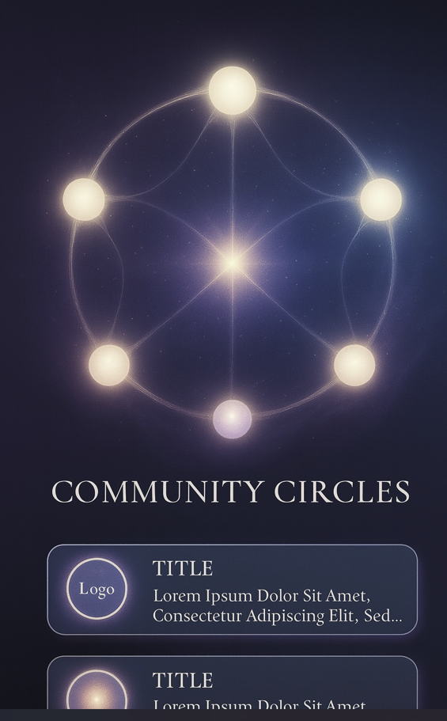

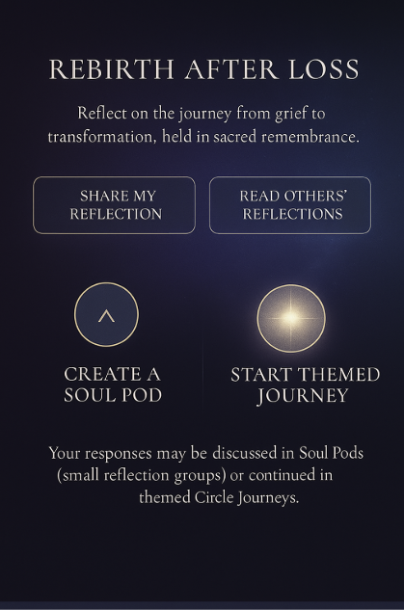

Share my reflection:

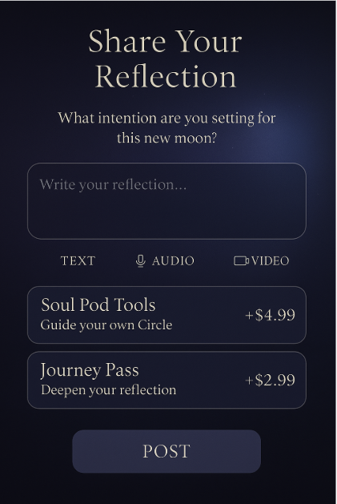

Read Others:

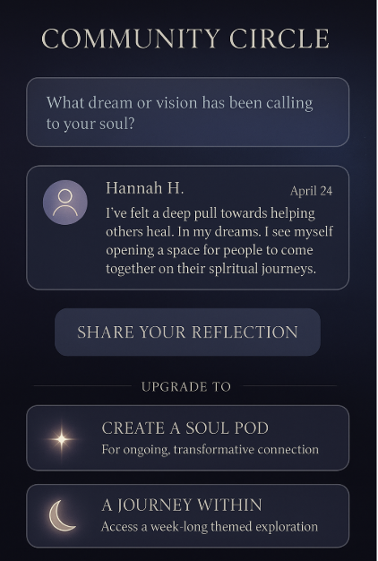

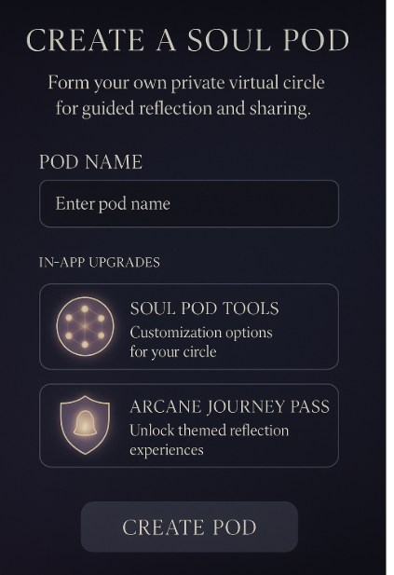

## **🌟 Soul Pod Tools Setup Screen**

*“Shape your Soul Pod’s sacred identity and energetic flow.”*

### **1. Pod Identity**

* **Pod Name** (auto-filled or editable)
* **Select an Archetype** *(Dropdown or icon selector with glyphs like Oracle, Weaver, Seer, Healer, Rebel, Visionary)* *“Choose the energetic signature that guides your circle.”*
* **Choose a Sigil or Symbol** *(Auto-generated based on archetype, or choose your own visual glyph)*
  + Option to upload or create your own sigil
  + Dynamic glow preview

### **2. Pod Container Settings**

* **Container Type** ⭕ Private (Invite only)  
   👁 Invite-only w/ visibility (listed but locked)  
   🌌 Hidden (Invisible in directory)
* **Circle Size Limit** (Dropdown: 3, 6, 9, 12 members)
* **Frequency Rhythm Selector**
  + Async only
  + Weekly Pulse
  + Bi-weekly Live
  + Custom rhythm (calendar interface)

### **3. Opening Ceremony Creation**

* Option to generate founding ceremony script using MirrorGPT
* Select tone: Sacred / Playful / Archetypal / Cosmic
* Add ambient music (choose a vibe: Deep Earth, Etheric Winds, Moonlight Flow)

### **4. Soul Ping Activation**

* Toggle: 🟢 Activate Soul Pings
* Choose prompt cadence:  
  + Weekly Activation
  + New Moon / Full Moon
  + Custom Oracle Delivery
* Add Whisper Tag Themes (e.g. Belonging, Grief, Love, Mystery)

### **5. Pod Agreements**

* Auto-generated Sacred Container Guidelines  
  + Respect + Listening
  + Witness, not fix
  + Consent before challenge
* Toggle optional agreements:  
  + Co-stewardship rotation
  + Shared ritual responsibility
  + Reflection response circle

### **6. Preview & Confirm**

* Shows:  
  + Pod name + glyph
  + Archetype symbol
  + Frequency
  + Next activation time

## **🌕 Invite to Circle – UX/UI Design + Functionality Overview**

### **🖼️ Visual Layout:**

**Header:** **Invite to Your Circle** Subtext: *Welcome others into your sacred space for reflection, sharing, and collective awakening.*

### **🔢 Section 1: Invite Method Selection**

**Buttons or Tabs for Invite Type:**

* 📧 **Email**
* 🔗 **Invite Link**
* 👥 **From Mirror Community**

### **📝 Section 2: Invite Form or Options**

**Option 1: Email Invite**

* Field to enter multiple emails (with "+" option)
* Optional message: *“Join me in the Soul Pod ‘Awakened Grace.’ Our next reflection begins Sunday.”*
* ✦ “Send Invitation” button
* Success confirmation animation (gentle glow or sacred sound)

**Option 2: Invite Link**

* Auto-generated secure link (e.g. mirror.collect/circle/awakened-grace)
* Copy button + Share to Messages, WhatsApp, Telegram
* Option to set:  
  + 🌗 **Max number of participants**
  + ⏳ **Expiration date/time**
  + 🕊️ **Open or Request-to-Join**

**Option 3: Invite from Mirror Community**

* Search bar to find other Mirror users
* Suggested contacts: Recently connected, similar journeys
* “Invite” button next to each name

**🔐 Access Settings (Modal or Optional Step)**

* Toggle:  
  + 🔒 Private (by invite only)
  + 🧭 Discoverable (visible in Circle listings)
  + 💬 Open Requests (people can request to join)

**🛠️ Product Functionality Notes:**

* All invites log user ID and status (Pending, Accepted, Expired)
* Push notification or email sent to invitee
* If they’re new to the platform: Redirect to **“Welcome to Mirror” onboarding + Circle Join Flow**
* If invite link is clicked after expiration: Soft modal with option to message Circle Host
* Ability to re-send, revoke, or view RSVP status on a **Circle Admin dashboard**

**🌟 Future-Ready Features:**

* **Invite with a Gifted Journey Pass** *“Come reflect with me. I’ve gifted you this themed journey to join our circle.”*
* **Soul Signature Invites** *Let MirrorGPT help write a poetic or soul-aligned invitation message.*
* **QR Code Generation** For in-person gatherings or spiritual retreats → scan and join instantly.
* Button: **ACTIVATE MY POD** (Triggers welcome screen and share link page)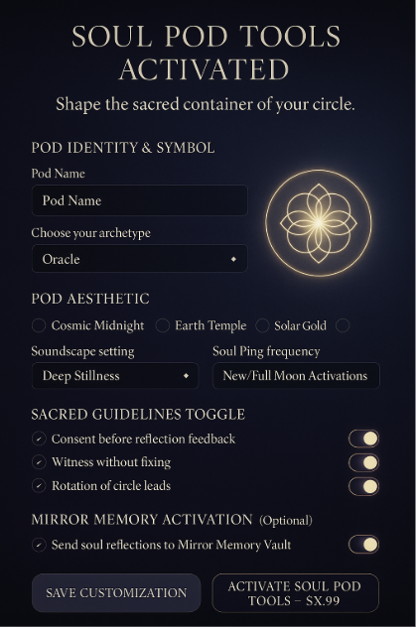

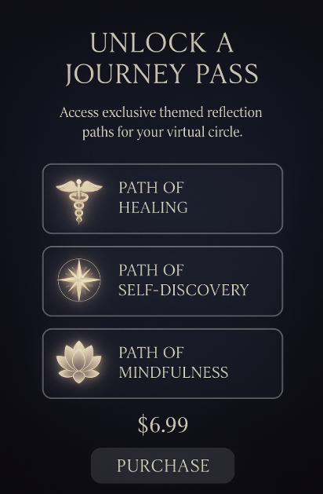

For the **"Unlock a Journey Pass"** screen, here's a detailed breakdown of what the **UX/UI** and **product functionality** should include for review:

### **🖼️ Visual Layout (UI Mockup Summary)**

**Header:** **“Unlock a Journey Pass”** Subtext: *Enter a themed space of reflection, awakening, and guided self-discovery.*

### **🔮 Featured Journey Cards (Carousel/Grid View)**

Each **Journey Pass** card includes:

* ✦ **Title** (e.g., “The Path of Remembrance”)
* ✦ **Icon or Image** (symbolic artwork aligned with the journey’s energy)
* ✦ **Brief Description** (1–2 sentences: "A 7-day reflective experience to awaken ancestral wisdom.")
* ✦ **Duration** (e.g., 7 Days, 30 Days)
* ✦ **Type**: Solo | Group | Facilitated
* ✦ **Price** (e.g., $3.99 one-time / or unlock with Premium+)

Tapping a card opens a **Journey Detail Modal** (see below).

### **🧭 Journey Detail Modal (Overlay or separate screen)**

Includes:

* ✧ Full description of the journey
* ✧ Sample themes/prompts (e.g., Day 1: “The Inner Child,” Day 2: “Shadow Embrace”)
* ✧ Format: text/audio/visual journey types
* ✧ MirrorGPT Integration: Yes/No
* ✧ Community Sharing: Optional/private/anonymous toggle
* ✧ Progress tracker visualization
* ✧ Unlock button (with price or membership benefit)

### **🛠 Functionality for Product & Engineering**

#### **1. Filter + Tag Options**

* Filters: Duration | Intensity | Focus (healing, creativity, grief, purpose, etc.)
* Tags: Solo, Group, Facilitator-led, Audio Guided, Journal-heavy, MirrorGPT-enabled

#### **2. Access Controls**

* If user is on Free tier, prompt upgrade or one-time unlock
* If Premium+, allow access with “Unlock Now” button and show “Included” badge

#### **3. In-App Purchase & Unlock Flow**

* Stripe or Apple/Google Pay integration
* Unlock triggers access to the Journey Room with:  
  + ✧ Daily unlocks or full release
  + ✧ Optional reminders (Soul Pings)
  + ✧ Personal Reflection Vault (text/voice/video)
  + ✧ Group Reflection Thread if enabled

### **💫 Additional Features**

* **Progress tracker:** Visually shows user’s completion through the journey
* **Invite a Friend to Journey Together** (optional)
* **Save to Favorites** for later
* **Gift this Journey** to another user (ideal for future release)

